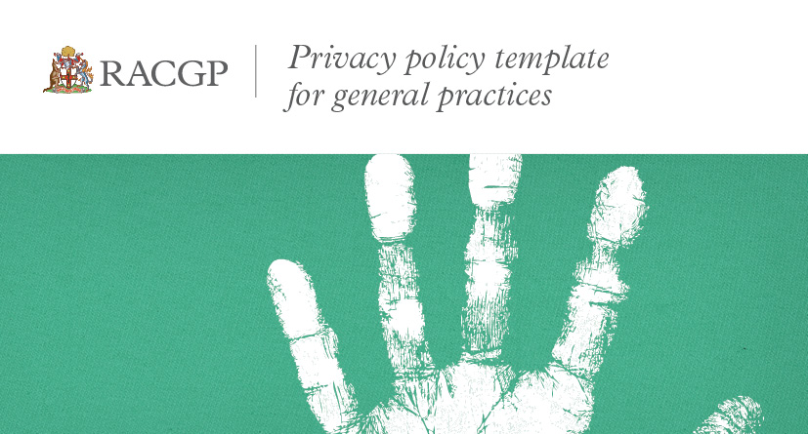

Clarence Medical Centre Privacy Policy
Current as of: 18 February 2016
Introduction
This privacy policy is to provide information to you, our patient, on how your personal information (which includes your health information) is collected and used within our practice, and the circumstances in which we may share it with third parties.
Why and when your consent is necessary
When you register as a patient of our practice, you provide consent for our GPs and practice staff to access and use your personal information so they can provide you with the best possible healthcare. Only staff who need to see your personal information will have access to it. If we need to use your information for anything else, we will seek additional consent from you to do this.
Why do we collect, use, hold and share your personal information?
Our practice will need to collect your personal information to provide healthcare services to you. Our main purpose for collecting, using, holding and sharing your personal information is to manage your health. We also use it for directly related business activities, such as financial claims and payments, practice audits and accreditation, and business processes (eg staff training).
What personal information do we collect?
The information we will collect about you includes:
- names, date of birth, addresses, contact details
- medical information including medical history, medications, allergies, adverse events, immunisations, social history, family history and risk factors
- Medicare number (where available) for identification and claiming purposes
- healthcare identifiers
- health fund details.
Dealing with us anonymously
You have the right to deal with us anonymously or under a pseudonym unless it is impracticable for us to do so or unless we are required or authorised by law to only deal with identified individuals.
How do we collect your personal information?
Our practice will collect your personal information:
- When you make your first appointment our practice staff will collect your personal and demographic information via your registration.
- During the course of providing medical services, we may collect further personal information. Information may collected through Electronic Transfer of Prescriptions (eTP), MyHealth Record/PCEHR system, eg via Shared Health Summary, Event Summary.
- We may also collect your personal information when you visit our website, send us an email or SMS, telephone us.
- In some circumstances personal information may also be collected from other sources. Often this is because it is not practical or reasonable to collect it from you directly. This may include information from:
- your guardian or responsible person
- other involved healthcare providers, such as specialists, allied health professionals, hospitals, community health services and pathology and diagnostic imaging services
- your health fund, Medicare, or the Department of Veteran's Affairs (as necessary).
Who do we share your personal information with?
We sometimes share your personal information:
- with third parties who work with our practice for business purposes, such as accreditation agencies or information technology providers – these third parties are required to comply with APPs and this policy
- with other healthcare providers
- when it is required or authorised by law (eg court subpoenas)
- when it is necessary to lessen or prevent a serious threat to a patient’s life, health or safety or public health or safety, or it is impractical to obtain the patient’s consent
- to assist in locating a missing person
- to establish, exercise or defend an equitable claim
- for the purpose of confidential dispute resolution process
- when there is a statutory requirement to share certain personal information (eg some diseases require mandatory notification)
- during the course of providing medical services, through Electronic Transfer of Prescriptions (eTP), MyHealth Record/PCEHR system (eg via Shared Health Summary, Event Summary).
Only people that need to access your information will be able to do so. Other than in the course of providing medical services or as otherwise described in this policy, our practice will not share personal information with any third party without your consent.
We will not share your personal information with anyone outside Australia (unless under exceptional circumstances that are permitted by law) without your consent.
Our practice will not use your personal information for marketing any of our goods or services directly to you without your express consent. If you do consent, you may opt-out of direct marketing at any time by notifying our practice in writing.
How do we store and protect your personal information?
Your personal information may be stored at our practice in various forms. We have some old paper records but mostly all personal information is stored electronically.
Our practice stores all personal information securely. Our electronic software is Best Practice which is formatted and a protected information system. We have passwords to access files and confidentiality agreements with all staff and our IT contractor.
How can you access and correct your personal information at our practice?
You have the right to request access to, and correction of, your personal information.
Our practice acknowledges patients may request access to their medical records. We require you to put this request in writing by when you attend your new practice sign a release form fax it to our surgery and your file will be sent either by fax or disk if required. Our practice will respond within a reasonable time usually 24 hours. If the file is large and requires more time we will respond within 7 days
Our practice will takes reasonable steps to correct your personal information where the information is not accurate or up-to-date. From time-to-time, we will ask you to verify your personal information held by our practice is correct and up-to-date. You may also request that we correct or update your information, and you should make such requests in writing to Clarence Medical Centre 1 Centenary Drive Maclean or email doctors@clarencemedical.com.au.
How can you lodge a privacy related complaint, and how will the complaint be handled at our practice?
We take complaints and concerns regarding privacy seriously. You should express any privacy concerns you may have in writing. We will then attempt to resolve it in accordance with our resolution procedure. Please contact Clarence Medical Centre Att: Practice Manager 1 Centenary Drive Maclean NSW 2463. Phone 02 6645 3299 or email manager@clarencemedical.com.au. We will respond to your concern within 7 days.
You may also contact the OAIC. Generally the OAIC will require you to give them time to respond, before they will investigate. For further information visit www.oaic.gov.au or call the OAIC on 1300 336 002.
Policy review statement
This privacy policy will be reviewed regularly to ensure it is in accordance with any changes that may occur.

Disclaimer
The template policy is intended for use as a guide of a general nature only and may or may not be relevant to particular practices or circumstances. The Royal Australian College of General Practitioners (RACGP) has used its best endeavours to ensure the template is adapted for general practice to address current and anticipated future privacy requirements. Persons adopting or implementing its procedures or recommendations should exercise their own independent skill or judgement, or seek appropriate professional advice. While the template is directed to general practice, it does not ensure compliance with any privacy laws, and cannot of itself guarantee discharge of the duty of care owed to patients. Accordingly, the RACGP disclaims all liability (including negligence) to any users of the information contained in this template for any loss or damage (consequential or otherwise), cost or expense incurred or arising by reason of reliance on the template in any manner.

