**Contacting the Medical Centre**

Phone number **02 6753 2020**

Fax number **02 9012 0582**

Email [**info@barwonmedicalcentre.com.au**](mailto:info@barwonmedicalcentre.com.au)

Opening Hours

Thallon branch: Tuesday 9am- 12pm Qld time

Main Practice (Mungindi): NSW time = daylight saving time

Thursday 8am to 5pm

Friday 8am to 5pm

Saturday 8am to 12pm

Reception receives all calls during business hours. Faxes and emails can be sent at any time of day.Calls, messages, faxes and emails are prioritised and attended to on the same day. Text messages are not reliably attended to

Out of Hours: If **urgent** or **life-threatening** dial **000**

For other medical care that is too urgent to wait until the next BMC opening day,   
ring the Mungindi hospital on 02 6705 6100, or The Medical Centre (St George) on 07 46255344.

For an appointment, leave a phone message or send an email with

* Name
* Contact Number
* Request for appointment day, time and type

All messages will be replied to within two working days.

Please don’t discuss clinical details other than appointment type by email   
– it is not secure, it only gives us part of the information to work with, and it may not get seen until two days later.  
 

**Available Services**

Consultations for a range of acute health issues

* Long appointments available on request
* SMS reminders for appointments
* PAP-smears, Implanon insertion
* Women’s, men’s and children’s health
* Skin checks
* Skin biopsies and small excisions
* Plaster casts
* Closing the gap – program sign-up
* Health assessments (bulkbilled)
* ECG, spirometry and blood collection (practice patients only)
* Home visits on request
* Pre-employment medicals
* Telehealth
* And much more!

**Obtaining Health Information**

For general health concerns, many brochures can be found in the Medical Centre waiting room. Please feel free to take any brochures home that are of interest to you.

For specific health concerns an appointment will need to be made with Dr Nadine to assess exact needs and appropriate care.

**Billing**

* We are a mixed billing practice
* We bulkbill pension card holders, children under 16 and DVA card holders, patients of Aboriginal and/or Torres Strait Islander origin and patients on a chronic disease care plan.
* There is a $5 discount for Health Care Card holders
* Standard privately billed consultation is $64 – claim your Medicare rebate with us on the day.
* Please complete your payment on the day.

**Follow-Up of Test Results**

If the doctor has requested tests on your behalf, it is important that you follow up on results.   
Please ring the receptionist for your test results during opening hours within a week of the investigation, unless we specify a longer time.

The receptionist may

1. Ask you to make another appointment to come in and discuss the results with the doctor within 2 weeks, or
2. Ask you to discuss the results with the doctor next time you are in for something else, or
3. Let you know that no further action is required at this stage.

**Privacy Policy**

Your privacy is of extreme importance to us, and we endeavour to respect and protect it in every possible way. Examples of how we protect your privacy:

* Other patients will not be able to see your file or your name in the appointment book.
* Background music is played to prevent your private consultation from being overheard.
* All building staff have signed a confidentiality agreement, stating that they will not discuss anything they find out in the normal course of their work, including your attendance at BMC.
* Reception staff only access your information where needed for the performance of their duties.
* Personal patient information is not visible to others, and the door of reception area is closed during breaks.

Nothing you discuss with the doctor is discussed with anyone else, unless one of these criteria fits:

1. You have given explicit verbal permission for the doctor to communicate with other health professionals about your details, including phone, email, fax
2. If there is ‘implied consent’ for the doctor to communicate with other health professionals  
    Example: you ask to be referred to an Orthopaedic surgeon, and the doctor writes a referral letter
3. If the doctor feels you are at risk of harm and you are underage  
    Example: physical abuse reported by an 11 year old
4. If the doctor feels you are at risk of harming yourself
5. If the doctor feels you are at risk of harming others
6. If some other law requires disclosure  
    Example: to notify Public Health of a case of Whooping cough under the NSW Public Health Act 1991

This practice audits its own performance against the optimal standards. For these audits we use, secure websites, including the National Prescribing Service clinical e-audit (www.nps.org.au) and the Skin Cancer Audit & Research database (<https://scard.skincanceraudit.com/>). Patient data are entered into these secure websites, but no one else has access to these data.

**Prescription of Medications**

* No cash and no drugs of abuse are available on BMC premises.
* BMC looks to identify patients who intend to obtain PBS medications in excess of what is required for their designated condition. Please don’t be offended if your request for increased amounts of medications is refused under the above conditions.
* When prescribing medications the doctors take all reasonable steps to ensure a therapeutic need exists and doctors do not prescribe to support drug dependence.
* It the patient’s responsibility to give a complete and accurate medical history to the Doctor and it is an offence not to do so with the purpose of obtaining drugs.
* Patient prescriptions are recorded on computer so that quantities and repeats supplied may be checked. eRx is also used.
* If “stockpiling” is suspected, this practice will refer the situation to the HIC, who, through their “Prescription Shopping Project” have statutory authority to explore the matter further.
* For any repeat prescription, an appointment is required.

If a drug of dependence is requested to be prescribed, Dr Goodman-Nadall will:

* Clearly ascertain the identity of the patient the prescription is for.
* Take all reasonable steps to ensure a genuine therapeutic need exists for the patient themselves.
* Not issue prescriptions to knowingly support a drug addiction.
* Not issue repeat prescriptions unless a pre-existing permit from NSW Department of Health exists
* Apply for a permit if intending to treat a patient with an S8 drug for more than 8 weeks.

For patients that are not regular BMC patients Dr Goodman will

* Consult a previous prescriber
* Contact NSW department of health
* Contact Prescription Shopping Information Service
* Insist on a further means of identification

These drugs will be supplied according to the regulations, therefore,

* supply will be absolutely according to recommended dosage
* supply may be less than allowable quantities.
* such supplies may not qualify for PBS subsidy.
* the earliest date of next prescription will be clearly recorded and adhered to
* Additionally, your pharmacist may be requested to limit supply to daily or a few days at a time.

**Feedback and complaints**

We would like to encourage all patients to give us feedback – positive and negative - about our performance. There are several ways of doing so:

* Verbally to reception staff
* Verbally to the doctor
* Via a letter, informal or formal complaint

If your issue is not resolved to your satisfaction, you can discuss it with the HCCC   
(Health Care Complaints Commission)

The Commission’s Inquiry Service handles inquiries from people who are concerned about the quality of the health care provided to them or to a family member or friend. Inquiries are usually made by telephone or email. Sometimes people visit the Commission’s offices.

Phone 02 9219 7444

Toll Free in NSW 1800 053 159

TTY service for the hearing impaired (02) 9219 7555

Fax (02) 9281 4585

Email [hccc@hccc.nsw.gov.au](mailto:hccc@hccc.nsw.gov.au)

Postal address Locked Mail Bag 18  
 Strawberry Hills NSW 2012

|  |  |  |  |
| --- | --- | --- | --- |
| |  |  |  | | --- | --- | --- | | |  |  | | --- | --- | | |  | | --- | |  | | | |
|  |

**eRx script Exchange**

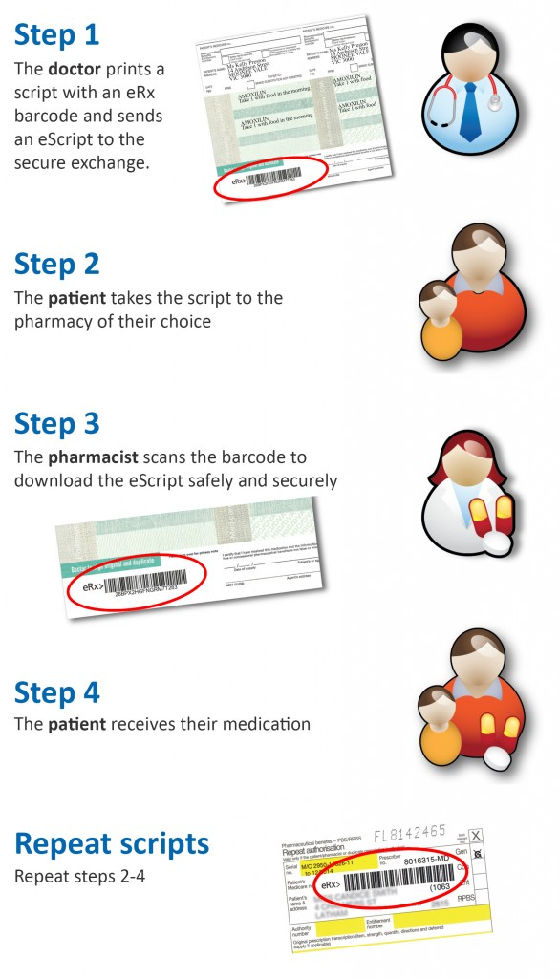

**What is eRx Script Exchange?**

eRx Script Exchange is an Australia-wide internet based gateway allowing prescriptions to be sent electronically and securely between GPs and pharmacies. It has been developed to improve patient safety by ensuring that the information on your prescription arrives at the pharmacy exactly as the doctor intended.

**Why are e-scripts important?**

• Electronic prescriptions reduce the chance of keying errors during dispensing, which enhances patient safety and strengthens confidence that you are getting the right medication at the right time

• You will have a better health care experience overall, as a result of improving coordination and management of care between GPs and pharmacies

• Advances in use of computer technology, such as eRx Script Exchange, are an important step in managing the growing health care costs in Australia.

**What happens?**

Your doctor will print a paper prescription as normal, but with an eRx barcode on it. At the same time, the prescription information is sent securely to eRx Script Exchange. You can then walk into any Australian pharmacy to have your medication dispensed. The pharmacist will scan your prescription barcode and this will retrieve your script information.

**Is my information secure?**

All of your personal and medication information is fully encrypted so that it is completely private and secure. Only your doctor and pharmacist can see your information, as they can now. eRx is not able to decrypt or see your information.

**Can I still choose which pharmacy I go to?**

Yes, you can still have your script dispensed at any pharmacy of your choice. If the pharmacy does not have eRx available, they will dispense your medication manually as they do today.

**Can I get my repeats at any pharmacy?**

Yes, you can go to any pharmacy for your repeats. Simply present the paper prescription with the eRx barcode to the pharmacy, and your electronic prescription will be retrieved from eRx, and dispensed.

**Do I have to pay?**

No, eRx is free for patients.

**What information is sent?**

The electronic prescription contains the same information as the paper prescription. There is a small amount of extra information sent about the drug itself to ensure that the correct medication can be matched to the pharmacy software.

**Who sees my information?**

Only the doctor and the pharmacy can see your information. Nobody else, including eRx, government, or any third party, can see your information.

**Will my data be provided to anybody else?**

No, not unless you ask us to. In future, we will be able to send your data to third parties to create an electronic health record, however, this will only be done with your full consent.

**Can I choose not to have my prescriptions sent to eRx?**

Yes. If you prefer not have your prescription information sent to eRx Script Exchange, please speak to your doctor or pharmacist.